Susan Burton
Aged 54?, Reg. No 419, Admitted Oct’. 12 1897
Reception Order Signed by V. Knightley Dated March 25th 1894
Copy of STATEMENT OF PARTICULARS
Sex and Age F. Age unknown, believed to be 50
Civil State Single Occupation Lodging House Keeper Religion C of E?
First Attack nk [not known] Age on first attack nk [not known]
When and where previously under treatment Berry Wood Northampton
Duration of present attack 7 months Supposed cause Religion
Suicidal Not known Dangerous to others and how Believed to be harmless
Any near relative afflicted with insanity Sister in an asylum
Union chargeable to Kensington Previous Place of Abode
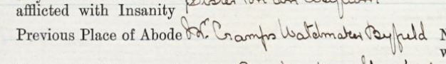
Name and Address of Person to whom Notice of Death to be sent Bro (as below)
Name and Addresses of one or more relatives of the Patient Geo Burton, Shoe Trade, Chapel St. Stafford
MEDICAL CERTIFICATE Signed by F W. Fowke
- Facts indicating insanity observed by myself at the time of examination viz.:-
During my examination the patient is ? 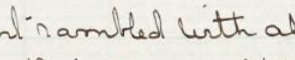with all kinds of nonsense & delusions. Fancied she was full of evil spirits & that nothing satisfied in the way of food – in fact if she took anything to eat the evil spirits & devils ear it. The holy spirit has been sent after her. The Virgin Mary wanted food. The Queen has bought a large house in London for her.
- Facts communicated by others viz.:- Geo: Burton (Brother) states she came unexpectedly to him from London in a very excited & strange manner, saying that her soul was wounded & that she was full of devils. Ordered extravagant luncheons both at Stafford & Northampton stations & had no money to pay for them.
HISTORY Whence obtained
[Empty]
Transferred from Berrywood Asylum In Ward A
CONDITION ON ADMISSION
General bodily condition Fair Nourishment Fair Deformities No
Scars, Bruises, or other sings of recent or old injury, pigmentations, eruptions or new growths No Sweat No Musculature Fair
Joints Nil
Hair colour Grey Texture Coarse Amount on cranium Fair
Colour of Irides Green Exophthalmos No Complexion Fresh
Grimacings No Furrows and lines of expression No
Physiognomy Pleasant Thyroid Nil Palate Nil
Tremors No Coordination and station Good
Tactile Sensation Good Sight Good Strabismus No
Movements of Eye Good Nystagmus No Ptosis No
Pupils – size equality Equal Outline Distinct
Mobility to light Good To accom. Good
Hearing Good Aural discharge No
VASCULAR SYSTEM – (Edema No Flush, Pallor or Cyanosis No
Varicose veins No Injection of cutaneous capillaries No
Arcus Senilis No Heart Nil
RESPIRATORY SYSTEM Cough Yes Examn. Of Lungs Nil
ALIMENTARY SYSTEM – Teeth Bad Gums Healthy
Tongue Clean Breath Nil Hepatic dullness Nil
Hernioe (state whether reducible) No
MENTAL STATE
Rambling & irrational in conversation * delusional. She makes curious noises 7 says they come from the small of her back where it pains her.
Signed A. Rotherham
Diagnosis Mania
Name Susan Burton
[Note attached – can’t read it]
PROGRESS OF CASE
Jan 14th 1900 Very irrational in conversation. Says work consists in making a noise
& that her work here is nearly finished. Fair health. A R.
April 15th She is incoherent in conversation & makes curious noises to herself.
Fair health. A. R.
July 4th Rambling & irrational. When spoken to as a rule becomes
bad tempered & excited. Makes curious noises says she cannot
breath [sic] unless she does so. Fair health. A. R.
Oct 29th Irrational & delusional. Believes that she has died & is
being slowly raised from the dead. This process not yet being complete. Excited & quarrelsome. Health fair.
Jan 16th 1901 She retains the above delusions & shows no signs of mental improvement. Rambling & irrational. Fair health. A. R.
April 9th Talks in the most irrational manner & works herself into an excited condition. Retains her delusions as above. Health fair. A. R.
July 14th There is no change in her condition & she shows no signs of mental improvement. Fair health. A. R.
Oct 14th She is very irrational & excitable. Retains her delusions. Fair health. A. H. E. ?
1902 Jan 15th She is very irrational both in talk and behaviour. Still makes curious noises & retains her delusions. Fair health. A. H.E.
April 10th No change mentally. Still makes curious noises. Health fair. C.
July 28th C Rude & abusive under examination. States that she is a Duchess ? incite the nurses to call her “Gee-Gee”. Health Fair.
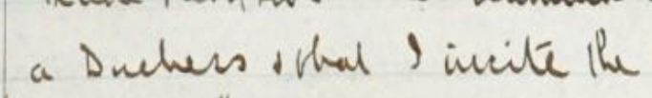
Oct 22 C Is not able to eat her dinner. Says she wants more strength. Has food delusions. Health good.
Nov 12 D D
Jan 9 D 1903 Always reading about 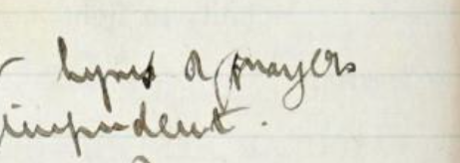
Idle. Rational. Impudent. Health fair. C. R.
April 20 D Patient very discontented. She ? the staff as “disgraceful idle lying ? always abusing her food & complains of ?? She has a tiger inside her. Health fair.
July 30th D Better behaved but still & at night owing to “tiger”. ?? Awake. Health fair.
Oct. 19 D Patient is very discontented and deluded about her joints. The food she says is horrible and wants beetroot. Health fair. CR.
Jan 26th C Patient very discontented with her food. Generally carries a bit of meat about with her. ?? Very noisy & abusive at times. Health fair. CR.
April 16th C Is very discontented especially about her food, says her joints are separating. In fair health. Removed to War D. CR.
July 19th D Patient says she is a duchess & has an animal inside of her. She is noisy at night. Cannot be made to do any word. Clean & health good.
Oct 27 D Irrational & ?? & discontented. D. Retains her delusions of grandeur. In fair health. CR.
Jan 25 D Irrational & at times noisy & abusive. Retains her delusions. Fair health. C. R.
April 8 D. Irrational & deluded, very noisy at night when she says a tiger is inside her, has outbreaks of excitement, fair health CR.
July 29 D. No mental change. Talks more irrational & deluded if anything. Good health. WEN.
3 Oct. D Very irrational, says she is a duchess, sometimes believes that there is a tiger in her bedroom. In fair health. C.R.
12 Jan 06 D Very deluded & irrational, with many ideas of grandeur, is noisy especially at night when she thinks there is a wild animal in her room. Fair health. CR.
Special report? & certificate.
Feb 24th Mania. Rambling & irrational in conversation. ??? delusions. Says she is ?? Duchess of Northampton & that Earl Spencer has ????. ? & abusive at times. ??? In fair health.
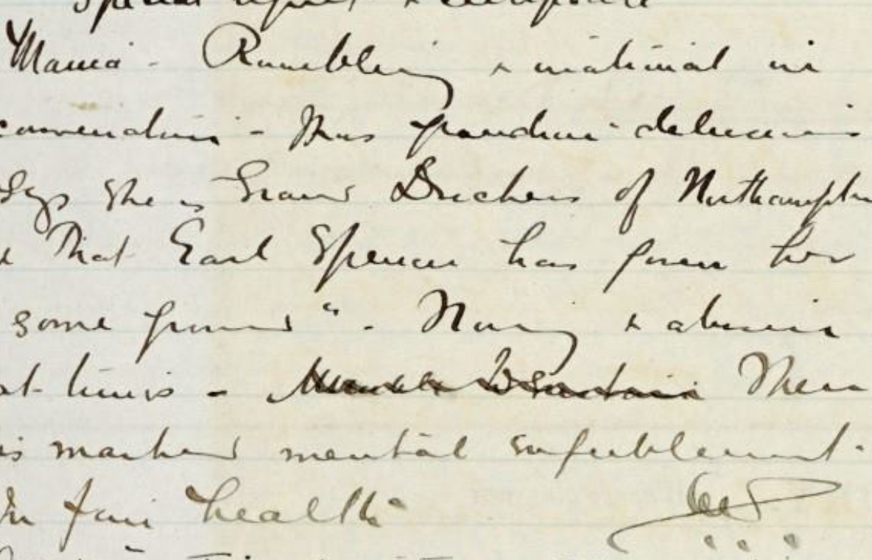
4 May D. Most irrational, with many grandiose ideas, noisy & abusive to the staff. In fair health. C. R.
7 Aug Very irrational & rambling/many ideas/fair health.
1 November D. Noisy & abusive, making groundless complaints against everyone & everything, says she is a titled & royal person, fair health CR.
1907 27 Feb Says she is a grand duchess & owns the asylum, very noisy at night, most abusive & discontented. Fair Health.
2 May Very noisy, continually interfering with the other patients & upsetting them. Believes she owns the asylum, most abusive. In fair health. C. R.
18 August D There is no change in her mental condition. Noisy, excited & abusive. Refuses to employ (?) herself. Fair health.
12 Nov D. Paranoia. Believes she is a duchess. ? of Royal birth, believes she is interfered with at night, very noisy & at times spiteful. Fair health. C.R.
1908 19 Feb Her delusions of grandeur persist. Believes she is an object of dislike to everyone in the ward. Fair health. CR.
12 May D. Noisy, excited and abusive. Is quite unable to give a sensible account of herself. Her delusions remain as before. Fair health. C.R.
12 Aug. Very noisy & abusive. Resents being asked questions. Her delusions persist. Health fair. FH
12 Nov. D. There is little change in her mental state. Very noisy. Fair health.
1909 12 Feb D. Very noisy & abusive, has many delusions of a grandiose nature, believes she is a grand duchess. In fair health.
12 May Remains noisy, abusive & rambling in her conversations.
30 June Was struck by Janes Jones with a chair & sustained a large bruise on the left temple & a black eye. FH.
7 July Transferred to Ward M. FH.
12 Aug M. Remains in a noisy & abusive condition. Her delusions persist. Fair Health. CR.
23 Nov M. Noisy & abusive, has many delusions of a grandiose nature, grumbles continuously at everything. Fair health. CR.
12 Feb. M. Noisy, excited & abusive, her delusions continue. Fair health. CR.
6 Apr. Transferred to Ward N.
12 May. Remains in the same noisy, excited & abusive condition, believes the staff threaten to murder her & want to burn her at the stake, believes she is a Duchess. Poor health. CR.
12 Aug. N Noisy & abusive. Her delusions persist. Poor health.
12 Nov. N Remains in a noisy, excited & abusive state, has many delusions of persecution. Poor health.
1911 13 Feb. N. There is little change in her condition. Noisy & abusive, thinks everyone is against her & talking about her. Fair health. CR.
24. Feb. Special Report Certificate
Chronic mania. Noisy, excited & abusive. States that the medical officers call her ‘pig, old cow, etc’ & claims to be the Grand Duchess of Northampton. Refuses to employ herself. Fair Health. MT.
13 May N. Refuses to speak about herself. Is noisy & troublesome at times. Idle. In fair health. CR.
12 Aug. N. Is very excited at times. Has many delusions of persecution. Fair health. [?] CR.
11 Nov N. Will not speak to me. Is noisy & abusive at times. Idle. Health fair. [?]
1912 12 Feb. N. Noisy & excited, has many delusions of persecution. Believes she is a Grand Duchess, continually grumbling about everything. Fair health.
13 May N. Still calls herself Duchess of Northampton & declares that the Medical Officer calls her an old pig & is most abusive to her. Fair health. MT.
29 June [crossed out]
Special Report & Certificate.
Secondary [?] Memory & intelligence greatly impaired. Thinks she is still at Stanwell. Cannot tell the day or month. Is noisy, resistive & troublesome. Cannot attend to herself. Fair health.
12 Aug. N. Remaining in the same noisy & deluded condition, grumbles about everything, especially her food. Fair health. CR.
12 Nov. Mental condition unchanged. Health fair.
1913 13 Feb. N. Noisy, excited & abusive, has many delusions of persecution. Believes she is persecuted by infidels & Jews in the ward. Fair Health. CR. Contd at Folio 20.
1916 Name Susan Burton. Cont.
Feb 10 G. Says she hears a tiger roaring & that I am to tell the Bishop & Lord Roseberry that it is all d__d nonsense. Is noisy & abusive. Idle. Fair health. MT.
Feb 25 Special report & certificate. Chronic mania.
Is noisy, garrulous & quarrelsome at times. Says she is the Grand Duchess of Northampton & the Earl Spencer has given her [?]. Very noisy occasionally at night & attributes her noisy condition to tigers. In moderate health.
June 26th She has developed facial erysipelas. Temp: has been up for the past two days, is having MGS04 applied.
July 1st Temp: normal since yesterday, face much better. Her health is very irregular.
July 6th She collapsed last night. She has some ether & Ammon, but refused to take it at all. I went down to down her [?] to inject her with strychnine, but she was dead on my arrival. CR.
Cause of Death as certified
- Senile Decay
- Heart Disease CR.

69/99 Q102 No. 419
COPY (WITHOUT NOTES) OF STATEMENT OF DEATH SENT TO CORONER.
Died 5th July 1916
Name Susan Burton
Sex and Age Female about 72 years
Married, single or widowed Single
Profession or occupation Lodging house keeper
Usual residence (postal address) Mr. Cramps Watchmaker, Byfield
before admission
Cause of death – Primary Senile Decay
- Secondary Heart Disease
Whether or not ascertained No
by post mortem examination
Time and any unusual circumstances 9.25.p.m
attending the death; also a description None
of any injuries known to exist at time
of death or found subsequently on
body of deceased or a statement
that there were none
Name and description of persons Nurse Janet Hale
present at the death
Whether or not mechanical restraint No
was applied to deceased within seven
days previously to death, with its
character and duration, if so applied

Signed, __ [?] ____ Med. Offr.

