Jane Sarah Reeve

See Private Case Book Page 53.

*Name* Jane Sarah Reeve, *Aged* 49, *Reg. No.* 392, *Admitted* 19.4.1900

*Copy of* STATEMENT OF PARTICULARS – [empty]

MEDICAL CERTIFICATE – [empty]

HISTORY – [empty]

CONDITION ON ADMISSION – [empty]

MENTAL STATE – See P.P. Case Bk

Private Case Book, 53

Date of Admission 19.4.1900

Jane Sarah Reeve, Age 49, Parish ?

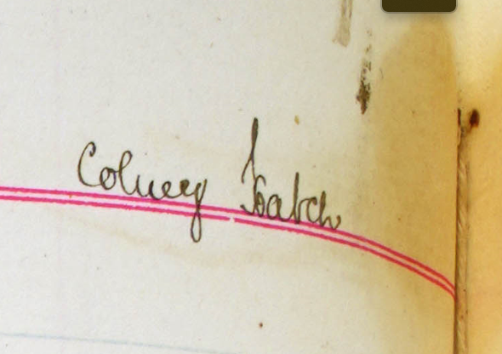

Order Signed by Edward Wood, Dated 8th May 1899

**Single, Married or Widowed** Single

**Condition of Life, and previous Occupation** None

**Religious Persuasion** Ch of Eng

**Previous Place of Abode** Wandsworth Infirmary

**If first Attack**  Yes

**Age on first Attack** 49 yrs

**When and where under previous care and Treatment** Nowhere

**Duration of existing Attack** Ten years. Worse of late

**Supposed Cause**  Hereditary

**Whether subject to Epilepsy** No

**Whether Suicidal** No

**Whether dangerous to others**  No

**Whether any near Relative has been affected with Insanity** Bro died in Caterham Asy

**Name and abode of nearest known Relative, and degree of relationship**  William Reeve (?, 11 Oxford Road, Putney

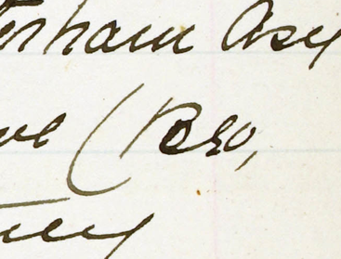

**Facts specified in Medical Certificate upon which opinion of Insanity is founded – 1. Facts indicating Insanity observed by Medical Man…**

She is full of delusions & subject to auditory hallucinations, complains of voices & unseen people addressing her, repeating her words & thoughts, interfering with everything she does or says. States that one communication referred to “Black Ink Case”. Declares that she heard through a telephone that her nephew had shot two people, fancies crowds of people stand about in the street apparently watching and speaking about her.

**2.- Other facts indicating Insanity communicated to him by others.**

Transferred to Private List 19.4.1900.

**Form of Disorder** Melancholia

**Admitted to Ward**  C

**Physical Condition on Admission** Fair

**External appearance, habit of body,** Pale women with grey hair. Habits  **temperament, expression of** clean. Expression dull.  **countenance, form of the head (if  
abnormal)**

**Eyes – vision: abnormality of other** Eyes brown. Pupils equal  **special senses, or of common   
sensibility**

**Pulse, tongue, skin and temperature** Nil  **if abnormal**

**Vascular and respiratory organs** Nil  **and abdominal viscera**

**Presence or absence of bruises or** No. ???  
**other injury, or if under restraint**  
**on admission**

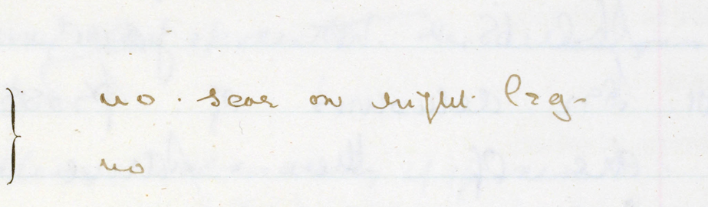

**Symptoms of Mental Disorder. – Probable period of attack; delusions, illusions, irrational conduct, morbid or dangerous propensities; memory and general intelligence; whether disorder is associated with epilepsy or paralysis; habits – whether cleanly or the reverse.**

She is full & worried & has delusions of persecution. Says the people in the street used to worry (???) her in every way

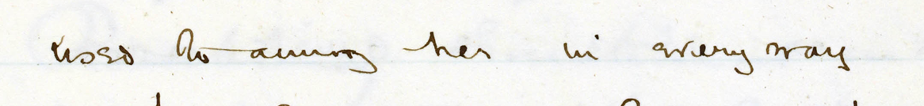& this used to be especially done by the Catholics at Putney, who kept her awake at night saying horrible things about her. They said they would knock about till they came to the end of the black ink case. She also heard other peoples voices talking against her thro9ugh the walls. It sounded like a

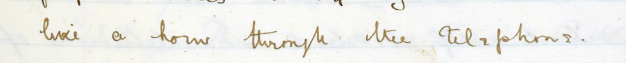?? through the telephone.

1. Rotherham.

**Previous History, ant facts that may be known.**